Test Case: tc001_SPX_Dev5_Crear_Requisicion_Spot_Tipo_Cobro_CC
Step 1 - Enter username and password and click to button Enter : Credentials Entered
Image file-name: QC_Testing-tc001_SPX_Dev5_Crear_Requisicion_Spot_Tipo_Cobro_CC-1784569220013

Step 2 - Select to UEN and Access to Spot Buy Requisitions : UEN Correctly selected and Correct access
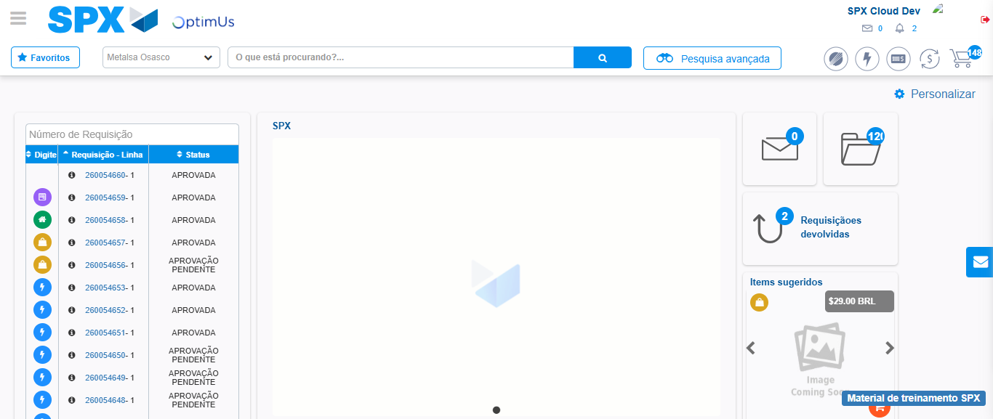Image file-name: QC_Testing-tc001_SPX_Dev5_Crear_Requisicion_Spot_Tipo_Cobro_CC-1784569299021

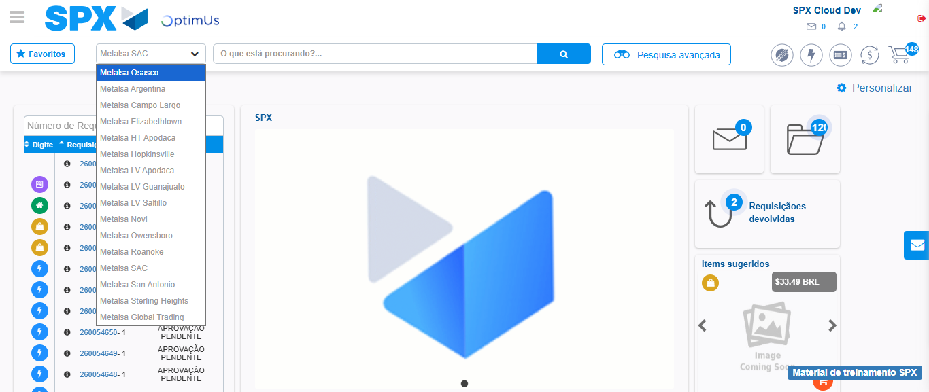Image file-name: QC_Testing-tc001_SPX_Dev5_Crear_Requisicion_Spot_Tipo_Cobro_CC-1784569301644

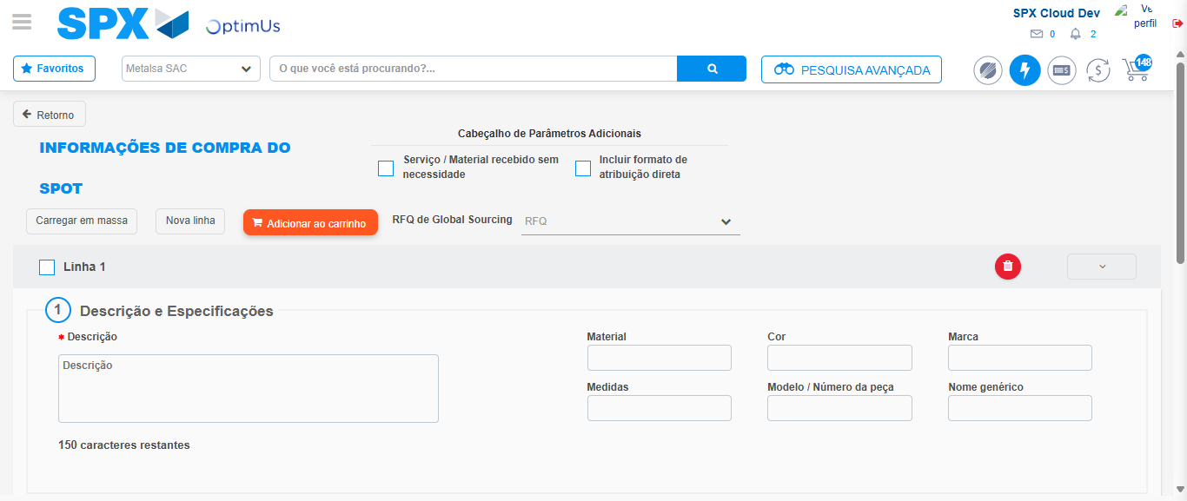Image file-name: QC_Testing-tc001_SPX_Dev5_Crear_Requisicion_Spot_Tipo_Cobro_CC-1784569317116

Step 3 - Data Capture Spot Buy Requisition : Data captured correctly
Image file-name: QC_Testing-tc001_SPX_Dev5_Crear_Requisicion_Spot_Tipo_Cobro_CC-1784569317389

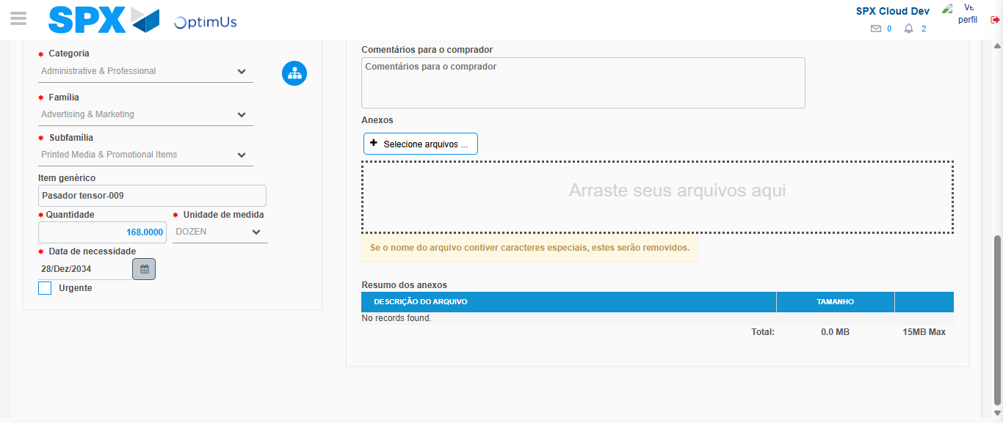Image file-name: QC_Testing-tc001_SPX_Dev5_Crear_Requisicion_Spot_Tipo_Cobro_CC-1784569330185

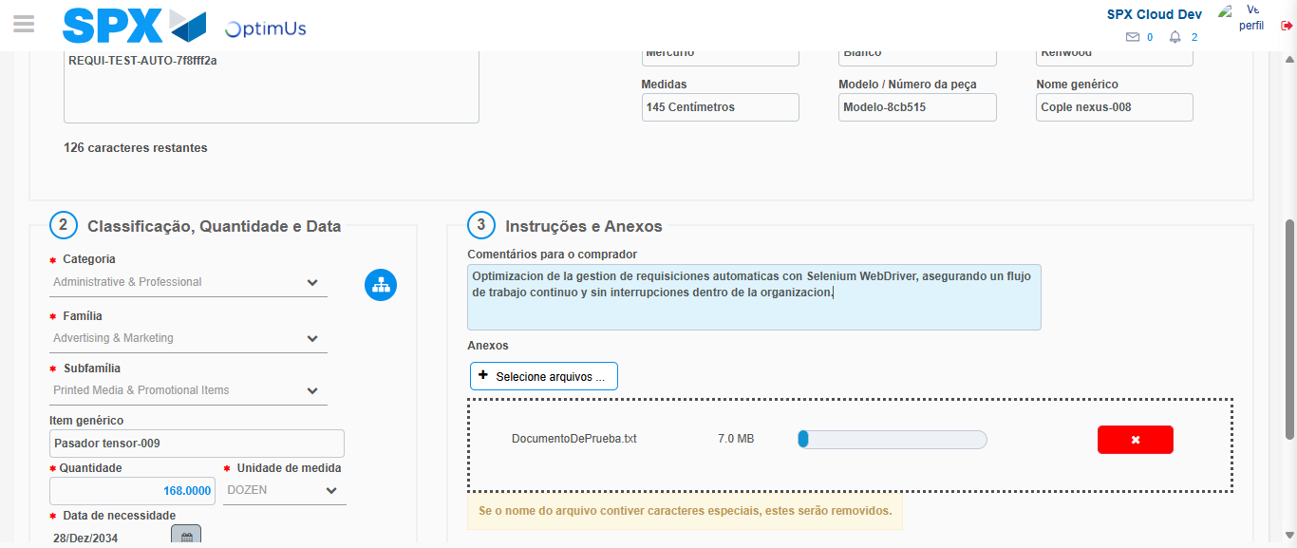Image file-name: QC_Testing-tc001_SPX_Dev5_Crear_Requisicion_Spot_Tipo_Cobro_CC-1784569331132

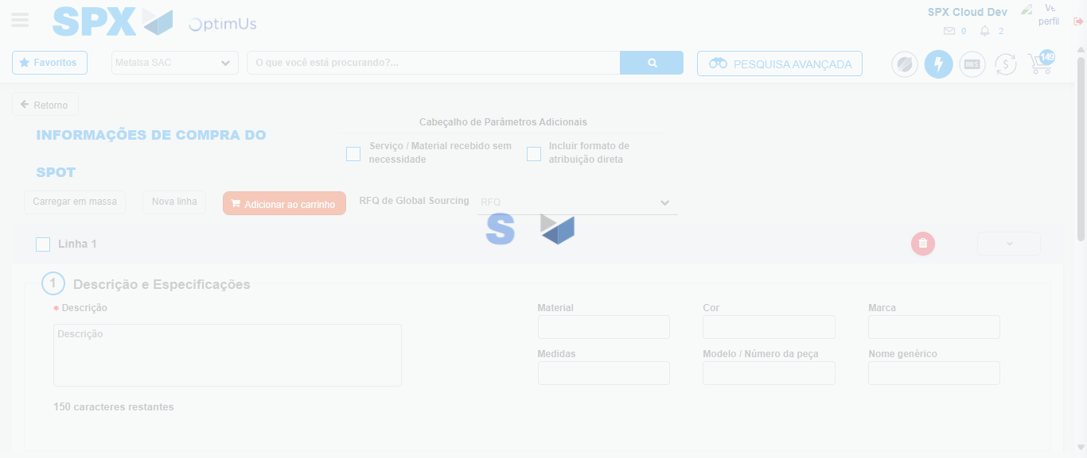Image file-name: QC_Testing-tc001_SPX_Dev5_Crear_Requisicion_Spot_Tipo_Cobro_CC-1784569345025

Step 7 - Return to Main Page SPX : Return to Main Page SPX
Image file-name: QC_Testing-tc001_SPX_Dev5_Crear_Requisicion_Spot_Tipo_Cobro_CC-1784569299021

Image file-name: QC_Testing-tc001_SPX_Dev5_Crear_Requisicion_Spot_Tipo_Cobro_CC-1784569301644

Image file-name: QC_Testing-tc001_SPX_Dev5_Crear_Requisicion_Spot_Tipo_Cobro_CC-1784569317116

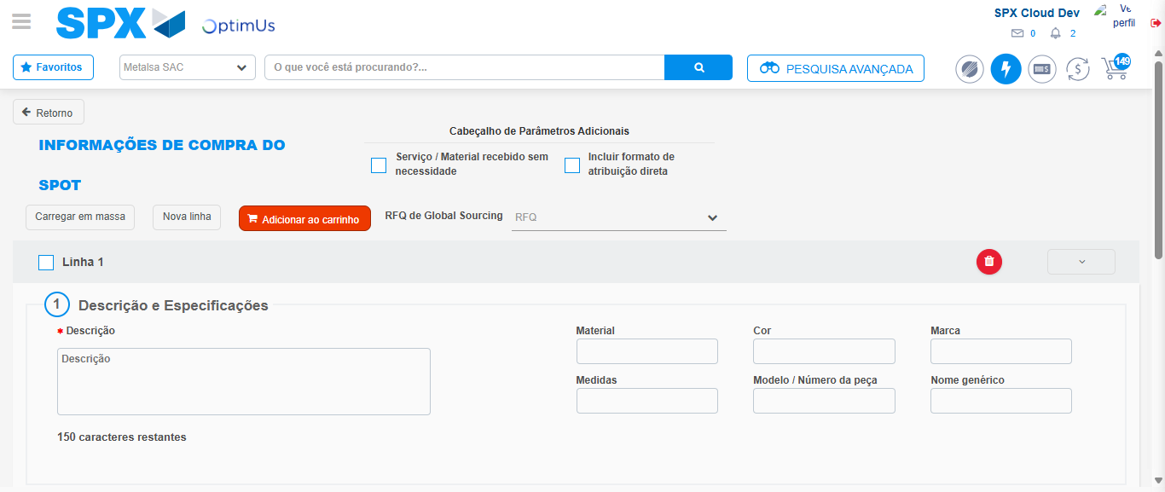Image file-name: QC_Testing-tc001_SPX_Dev5_Crear_Requisicion_Spot_Tipo_Cobro_CC-1784569347349

Image file-name: QC_Testing-tc001_SPX_Dev5_Crear_Requisicion_Spot_Tipo_Cobro_CC-1784569347571

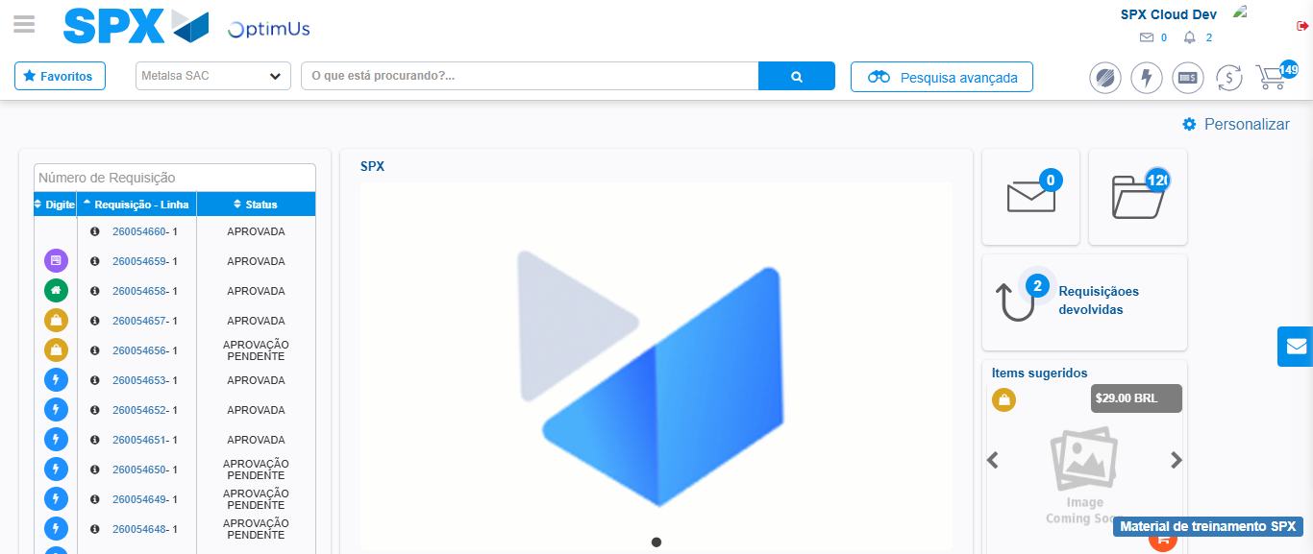Image file-name: QC_Testing-tc001_SPX_Dev5_Crear_Requisicion_Spot_Tipo_Cobro_CC-1784569368879

Step 8 - Log Out : Log Out SPX
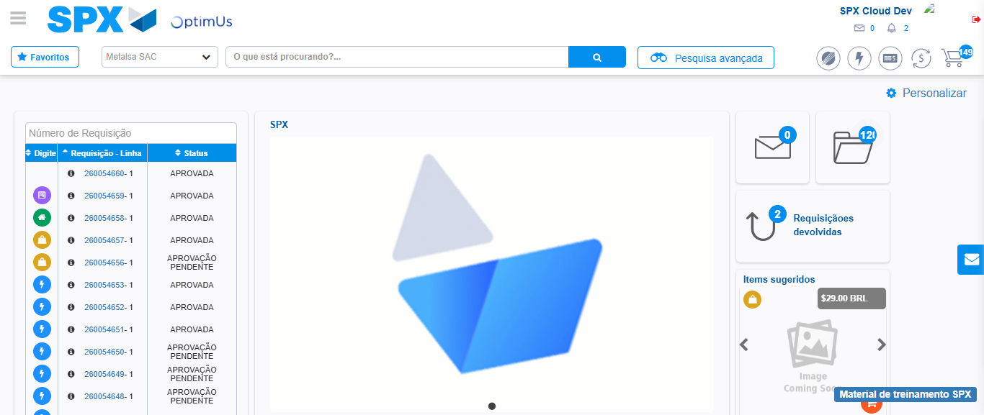Image file-name: QC_Testing-tc001_SPX_Dev5_Crear_Requisicion_Spot_Tipo_Cobro_CC-1784569369217

